CHEMICAL BONDING AND MOLECULAR STRUCTURE
B.Sc(Hons) ,Part I/ II, Inorganic chemistry, Lecture No. 1
Dr. KHAN
Associate professor, Purnea College, Purnea
Genera Descriptions
- Matter is made up of one or different type of elements. Under normal conditions no other element exists as an independent atom in nature, except noble gases. However, a group of atoms is found to exist together as one species having characteristic properties. Such a group of atoms is called a molecule.
- Obviously there must be some force which holds these constituent atoms together in the molecules. The attractive force which holds various constituents (atoms,molecules , ions, etc.) together in different chemical species is called a chemical bond with a condition that some new things must be formed.
- The formation of chemical compounds takes place as a result of combination of atoms of various elements in different ways, it raises many questions like
- Why do atoms combine?
- Why are only certain combinations possible?
- Why do some atoms combine while certain others do not?
- Why do molecules possess definite shapes? and etc.
4.To answer such questions different theories and concepts have been put forward from time to time
Such as
a. Kössel-Lewis approach,
b. Valence Shell Electron Pair Repulsion (VSEPR) Theory,
c. Valence Bond (VB) Theory ,and
d. Molecular Orbital (MO) Theory.
5. The evolution of various theories of valence and the interpretation of the nature of chemical bonds have closely been r elated to the developments in the understanding of the structure of atom.
6. Every system tends to be more stable and bonding is nature’s way of lowering the energy of the system to attain stability
7. Lewis pictured the atom in terms of a positively charged ‘Kernel’ (the nucleus plus the inner electrons) and the outer shell that could accommodate a maximum of eight electrons. This octet electrons, represents a particularly stable electronic arrangement.
8. Lewis postulated that atoms achieve the stable octet when they are linked by chemical bonds. In the case of sodium and chlorine, this can happen by the transfer of an electron from sodium to chlorine thereby giving the Na+ and Cl– ions.
9. In the case of other molecules like Cl2 , H2 , F2 , etc., the bond is formed by the sharing of a pair of electrons between the atoms. In the process each atom attains a stable outer octet of electrons.
10. Lewis Symbols: In the formation of a molecule, only the outer shell electrons take part in chemical combination and they are known as valence electrons. These notations are called Lewis symbols or Electronic formula or Dot structure.
For example,-
- The group valence of the elements is generally either equal to the number of dots in Lewis symbols or 8 minus the number of dots or valence electrons.
- Kössel and Lewis in relation to chemical bonding, drew attention to the following facts:
I In the periodic table, the highly electronegative halogens and the highly electropositive alkali metals are separated by the noble gases;
II . The formation of a negative ion from a halogen atom and a positive ion from an alkali metal atom is associated with the gain and loss of an electron by the respective atoms;
III. The negative and positive ions thus formed attain stable noble gas electronic configurations. The noble gases (with the exception of helium which has a duplet of electrons ns² configuration) have a particularly stable outer shell configuration of eight (octet) octet configuration- ns2np6.
IV. The negative and positive ions are stabilized by electrostatic force of attraction.
For example-
Tthe formation of NaCl from sodium and chlorine, according to the above scheme, can be explained as under:
Na → Na+ + e–
[Na] 3s1 [Ne] 2s² 2p⁶ 3s0

Cl + e⁻ → Cl⁻
[Cl] 3s²3p⁵ [Ar] 3s²3p⁶

Na+ + Cl– → NaCl or Na+Cl–
Similarly the formation of CaF2 may be shown as:
Ca → Ca2+ + 2e– [Ar]4s 2
[Ar] F + e– → F–] Ca2+ + 2F– → CaF2 or Ca2+ (F – )2
V. The bond formed, as a result of the electrostatic force of attraction attraction between the positive and negative ions was termed as electrovalent bond or ionic bond.
VI.The electrovalence is thus equal to the number of unit charge(s) on the ion. Thus, calcium is assigned a positive electrovalence of two, while chlorine a negative electrovalence of one.
VII. According to this, atoms can combine either by transfer of valence electrons from one atom to another (gaining or losing) or by sharing of valence electrons in order to have an octet in their valence shells. This is known as octet rule.
VIII. Covalent Bond Langmuir (1919) refined the Lewis postulations by introducing the term covalent bond. The Lewis-Langmuir theory can be understood by considering the formation of the chlorine molecule,Cl2 as under-
IX. The Cl atom with electronic configuration, [Ne]3s 2 3p 5 , is one electron short of the argon configuration.
X. The formation of the Cl2 molecule can be understood in terms of the sharing of a pair of electrons between the two chlorine atoms, each chlorine atom contributing one electron to the shared pair.
In the process both chlorine atoms attain the outer shell octet of the nearest noble gas (i.e., argon).
XI. The dots represent electrons. Such structures are referred to as Lewis dot structures. The Lewis dot structures can be written for other molecules also, in which the combining atoms may be identical or different.
XII. The important conditions being that:
• Each bond is formed as a result of sharing of an electron pair between the atoms.
• Each combining atom contributes at least one electron to the shared pair.
• The combining atoms attain the outershell noble gas configurations as a result of the sharing of electrons.
• Thus, formation of covalent bonds can be represented as: or Cl – Cl Covalent bond between two Cl atoms Thus, when two atoms share one electron pair they are said to be joined by a single covalent bond.
The formation of multiple bonds envisages sharing of more than one electron pair between two atoms.. For example, in the carbon dioxide molecule, we have two double bonds between the carbon and oxygen atoms.

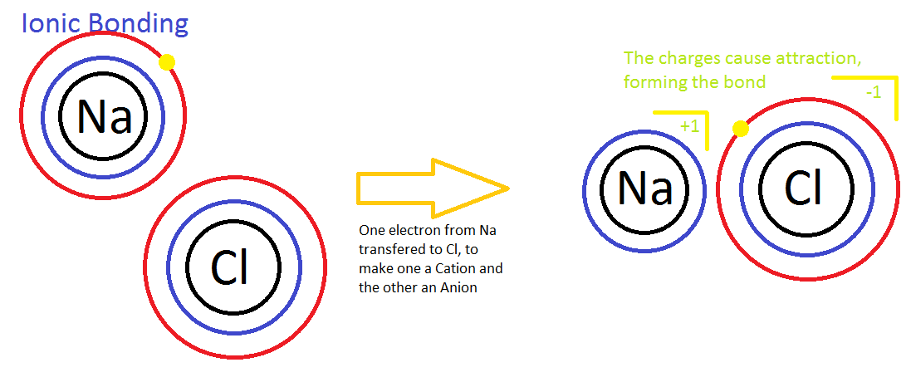

Ionic bond vs Covalent Bonds –A brief summary
:
 | Ionic Bonds | Covalent Bonds
Description | Bond between metal and nonmetal. The nonmetal attracts the electron, so it's like the metal donates its electron to it. | Bond between two nonmetals with similar electronegativities. Atoms share electrons in their outer orbitals.
Polarity | High | Low
Shape | No definite shape | Definite shape
Melting Point | High | Low
Boiling Point | High | Low
State at Room Temperature | Solid | Liquid or Gas
Examples | Sodium chloride (NaCl), Sulfuric Acid (H₂SO₄ ) | Methane (CH₄), Hydrochloric acid (HCl)
Chemical Species | Metal and nometal (remember hydrogen can act either way) | Two nonmetals

